**EXP : 5** IMPLEMENT PROGRAMS FOR ESTIMATING & ELIMINATING TREND

**DATE : 27.03.2025** IN TIME SERIES DATA- AGGREGATION, SMOOTHING

**AIM:**

Implement programs for estimating & eliminating trend in time series data- aggregation, smoothing

**PROCEDURE:**

**STEP 1:**

import pandas as pd

import numpy as np

import matplotlib.pyplot as plt

from statsmodels.tsa.api import ExponentialSmoothing

**STEP 2:**

file_path = '/content/LBMA-SILVER.csv'

df = pd.read_csv(file_path, parse_dates=['Date'], index_col='Date')

df = df.sort_index()

df = df.sort_index()

df.plot(title='Original Time Series', figsize=(15,5))

plt.show()

**STEP 3:**

df_monthly = df.resample('M').mean()

df_monthly.plot(title='Monthly Aggregated Time Series', figsize=(10,5))

plt.show()

**STEP 4:**

window_size = 10

df['Moving_Avg'] = df.iloc[:, 0].rolling(window=window_size).mean()

df[['Moving_Avg']].plot(title='Moving Average Smoothing', figsize=(20,5))

plt.show()

**STEP 5:**

window_size = 10

df['Moving_Avg'] = df.iloc[:, 0].rolling(window=window_size).mean()

df[['Moving_Avg']].plot(title='Moving Average Smoothing', figsize=(20,5))

print(df.head())

**OUTPUTS:**

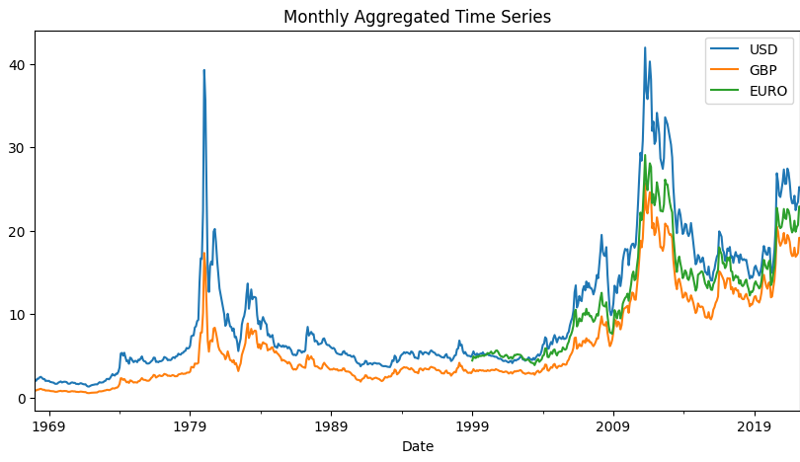

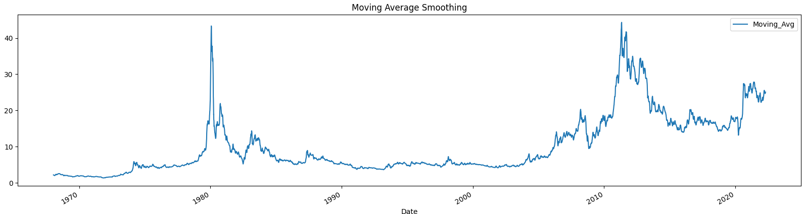

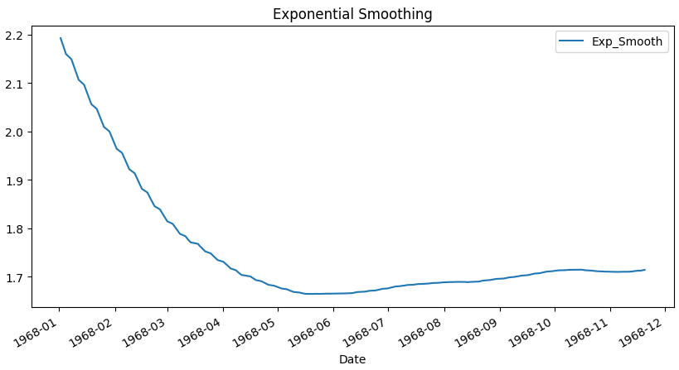

**RESULT:**

The program to execute estimating & eliminating trend in time series data- aggregation, smoothing has been executed successfully.